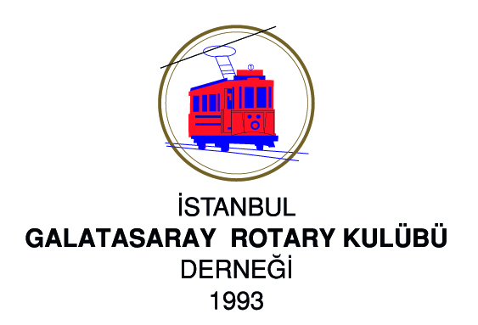


Galatasaray Rotary Club - Introduction

Definition of Rotary Rotary is an organization of business and professional people from around the world who serve humanity, promote and promote the use of high moral standards in every profession, and help promote peace and goodwill in the world.

2025 – 2026 RI President

Francesco Arezzo ve wife Anna Maria Arezzo-Criscione
“Live, transform, share Rotary!”

District 2420 Governor 2025 – 2026
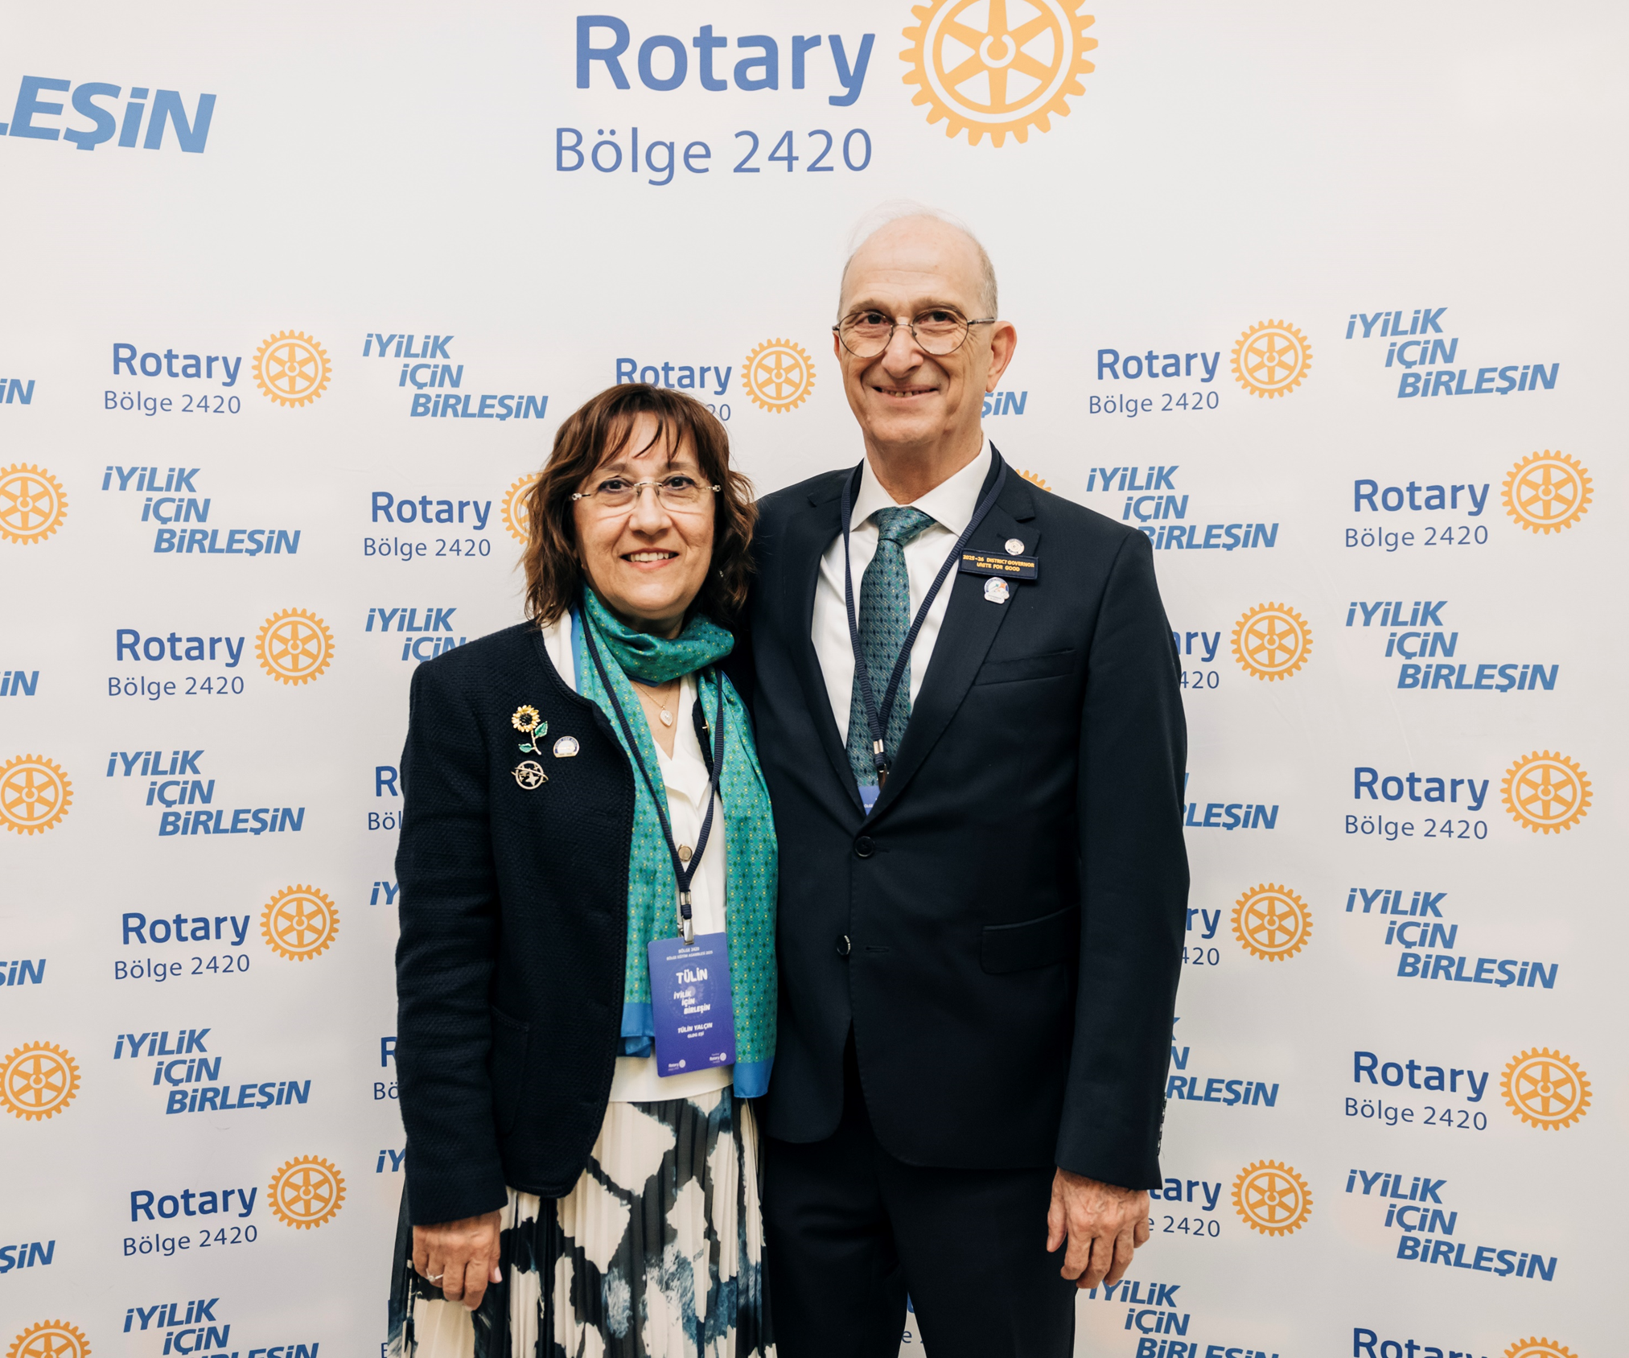
Fuat Yalçın ve wife Tülin Yalçın

History of Our Club
Founded: 18 March 1993
Charter: 25 October 1995
Meeting Place: Gayrettepe Dedeman Hotel Meeting
Time: Friday 07:30 (First and last Friday of each month,twice on Zoom)
Founding President: Rtn. Bülent Akman
Governor of the Time: Rtn. Ferit Biren
Founding Members: Recep Bülent Akman, Yusuf Aslanoğlu, Mehmet İlker Aşık, Oğuz Atabek, Nezih Atalay, Tahir Rüştü Baç, Halil Bahçecioğlu, İlyas Atlan Begiter, Cihan Bingöl, Can Hemşinlioğlu, Yılmaz İnan, Sabri Kurdoğlu*, İrfan Papila, Mehmet Tınaztepe, Ömer Fikret Yalkın*, Kemal Yaranona (*Founders who are still members)

Membership
24 Members
Honorary Members: Fikret Satana and Ali Akgün

Club President
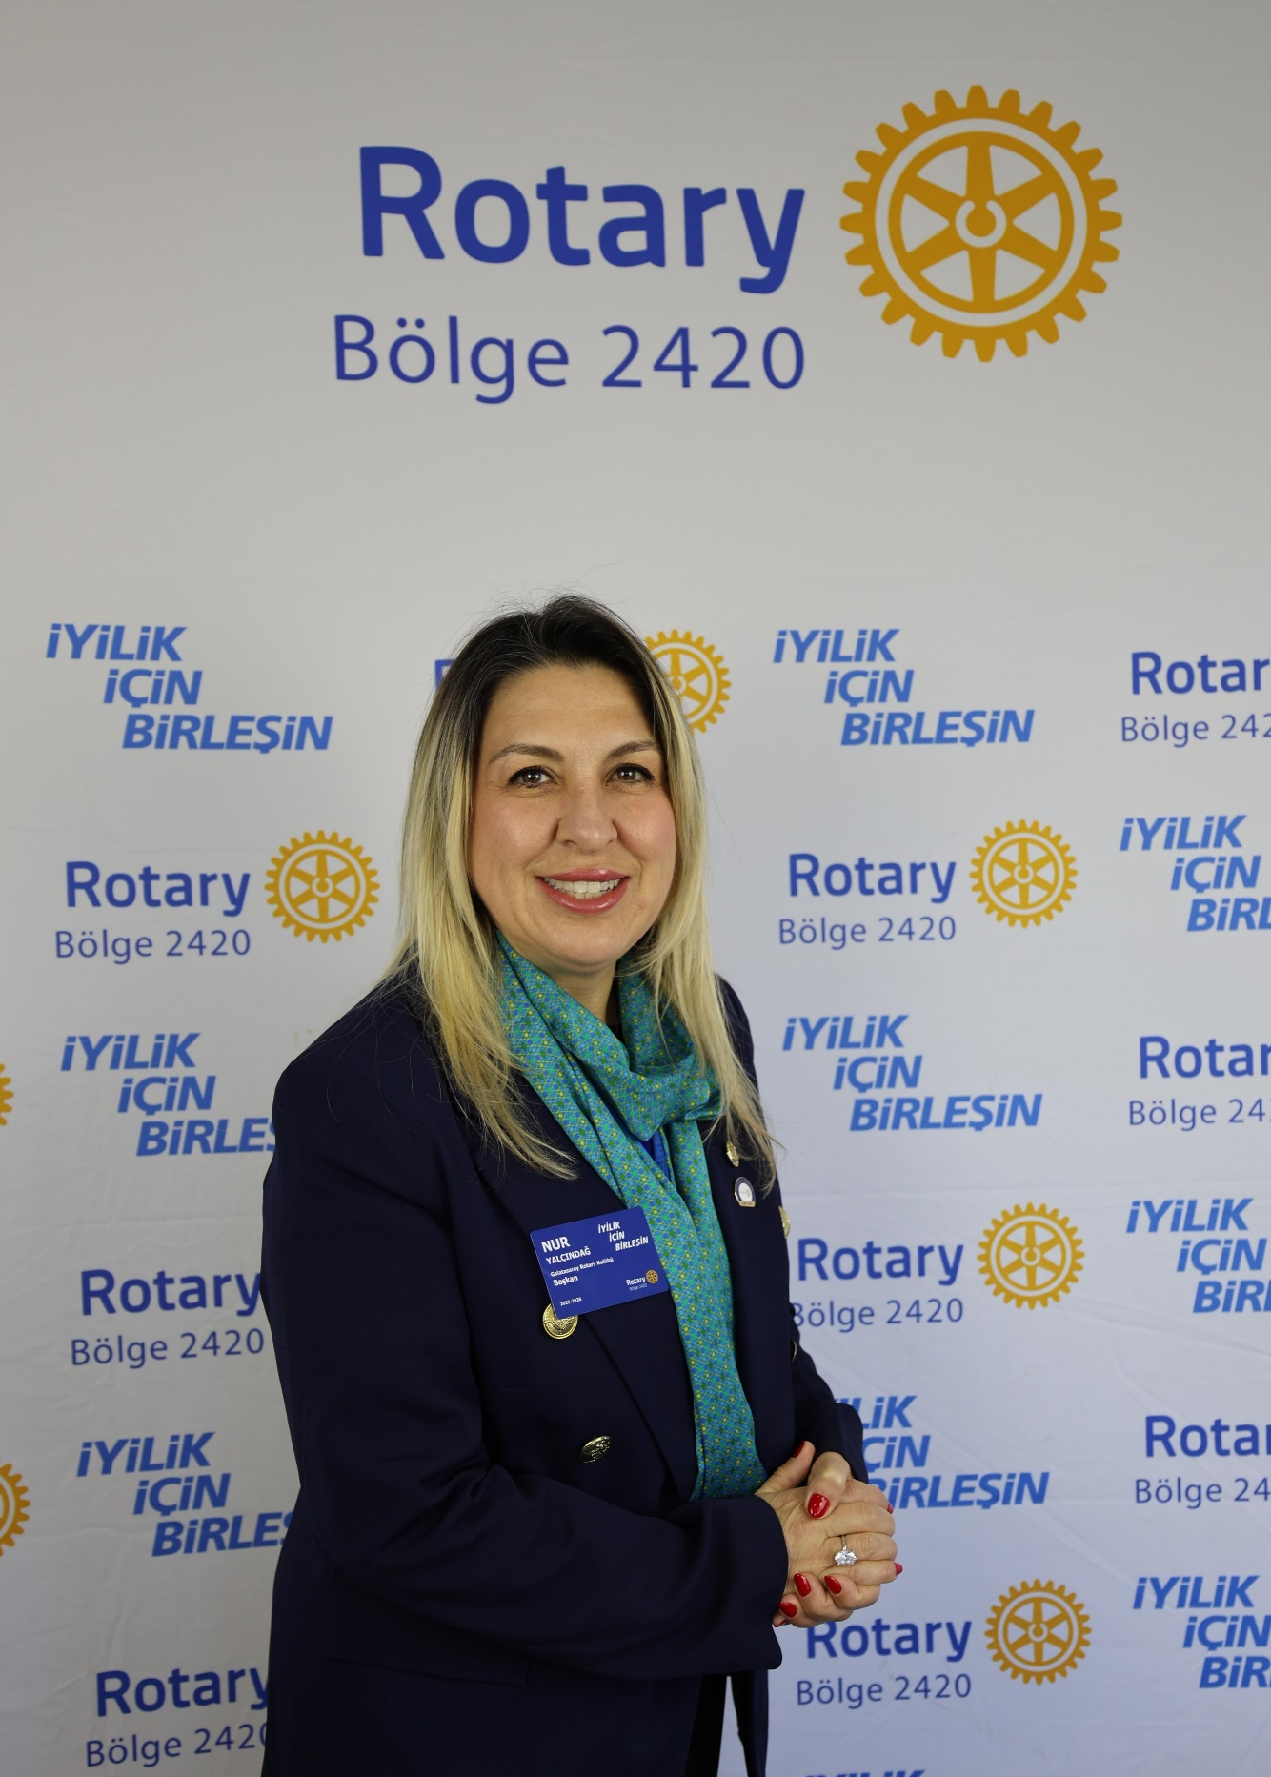
Nur Yalçındağ (2025-2026)
Biography: Coming from a Rotarian family, she became a member of Rotary in 2002. She held various positions at the district. In her business life, she exceled in the field of financial asset management and is a woman entrepreneur in washroom equipment industry.

Board of Directors
Club President: Nur Yalcindag
President Elect: Kerem Kılıc
Club Secretary: Erman Kızılkan
Treasurer: Sabri Kurdoglu
Past President: Selda Gerşon

Club Peace Counselor

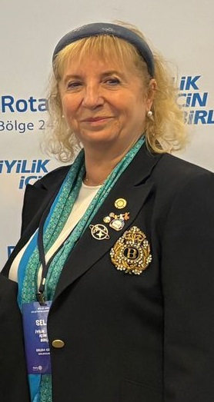
Selda Gerşon

Committees and Committee Chairs
Club Foundation Chair: Sait Feyzioğlu
Club Membership Chair: Selda Gerşon
Club Young Leaders Contact: Mürvet Dökücü
Club Public Image Chair: A. Erman Kızılkan
Club Learning Facilitator: Ceyda Tüfekçi
Club Service Projects Chair: Z. Ece Büyükutku
Club Classification & Professional Services: C. Eren Lokumcu

Main Projects
- Morning Conversations with Influential People (July 2025-June 2026)
- Projects to Create the Habit of Reading Books (September 2025 – June 2026)
- Polio & Health Awareness Projects (October 2026 & February 2026)
- Women's Panel (March 2026)
- Career Day for the Disabled (April 2026)
- Youth Forum (May 2026)
-Classroom for Mind Games and Brain Teasers Project for Public Schools (June 2026)
-Global Grant Projects for Hospitals

